Project Name: FIND YOUR DOCTOR(FYD)

**Team member:**

1. Sabbir Hosen (ID: 18201076)
2. Shahriar Shafin (ID: 18201070)

**Project objectives:**

1. This a web based virtual assistant
2. Find right doctor on the basis of your problems, symptoms and specialist.
3. Get doctor full information like name, designation, specialist, hospitals, Consulting time, fees, and days.
4. collect all problems and symptoms, after analysing the data it will suggest you the best doctor in specific sector.

**Query for the project**

**E-R Diagram:**

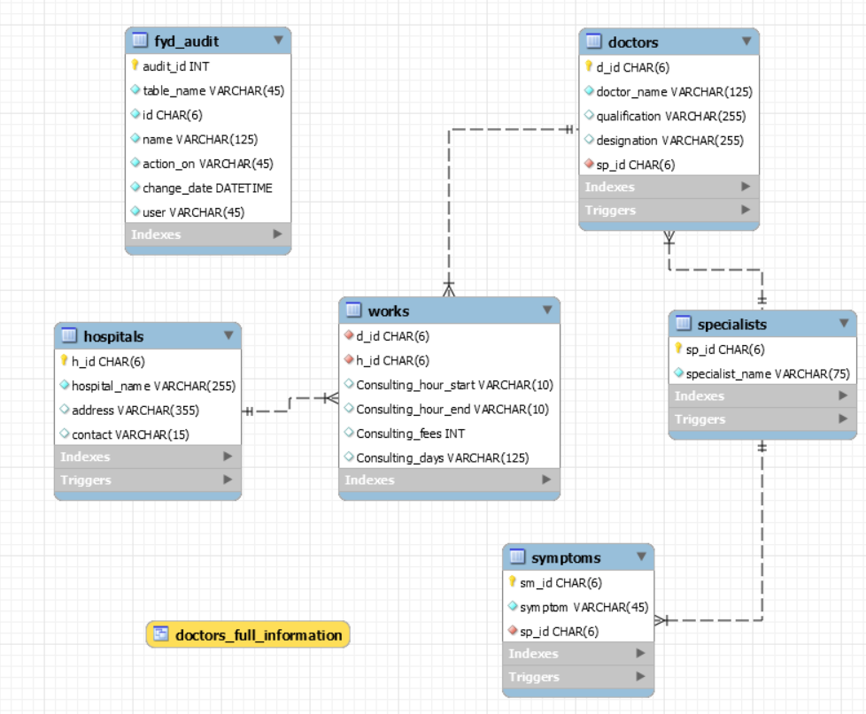

**Views for the project:**

|  |
| --- |
| **doctors_full_information** |
| d_id  doctor_name  qualification  designation  specialist_name  hospital_name  address  contact  Consulting_hour_start  Consulting_hour_end  Consulting_fees  Consulting_days |

Query for create view:

CREATE VIEW doctors_full_information AS

SELECT

d.d_id,

d.doctor_name,

d.qualification,

d.designation,

s.specialist_name,

h.hospital_name,

h.address,

h.contact,

w.Consulting_hour_start,

w.Consulting_hour_end,

w.Consulting_fees,

w.Consulting_days

FROM

doctors d

JOIN

works w USING (d_id)

JOIN

hospitals h USING (h_id)

JOIN

specialists s USING (sp_id);

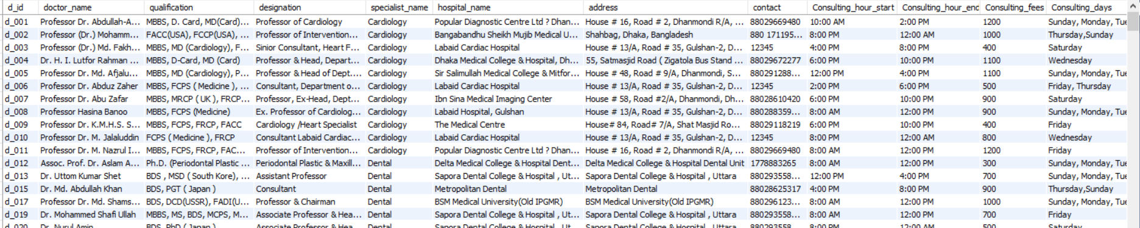

**Store procedures:**

CREATE DEFINER=`root`@`localhost` PROCEDURE `fyd_audit_table`(

table_name varchar(45),

id char(6),

name varchar(125),

action_on varchar(45),

change_date date,

user varchar(45)

)

BEGIN

insert into fyd_audit

set

audit_id = default,

fyd_audit.table_name = table_name,

fyd_audit.id = id,

fyd_audit.name = name,

fyd_audit.action_on = action_on,

fyd_audit.change_date = change_date,

fyd_audit.user = user;

END

**Triggers on doctors, hospitals, symptoms and specialist tables on insert update and delete actions.**

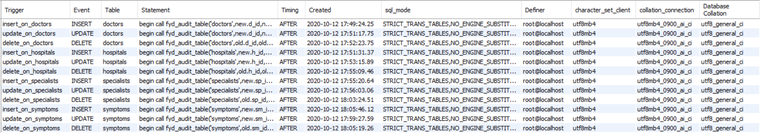

**Query**

*I’ll attached a “Query.sql” at attachment that contains all the query.

**1. Find doctors using a specialist name.**

Specialist names are-

* Cardiology
* Dental
* Dermatology
* Eye
* ENT
* Gynaecology and Obstetrics
* Gastroenterology
* Hepatologists
* Haematology
* Medicine
* Nephrologists
* Neuromedicine
* Orthopaedics
* Psychologist
* Endocrinologists
* Pediatric
* Urology

Find doctors specialist is ENT:

**SELECT**

d.doctor_name, d.qualification, d.designation

**FROM**

doctors d

**WHERE**

sp_id = (**SELECT**

sp_id

**FROM**

specialists

**WHERE**

specialist_name **REGEXP** '^ENT');

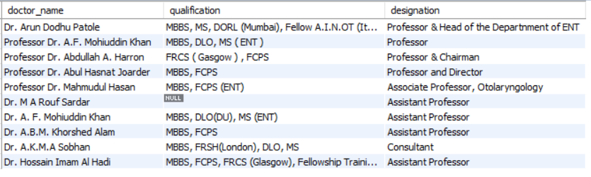

**2. Find doctors all information specialist is ENT:**

**SELECT**

**\***

**FROM**

doctors_full_information

**WHERE**

d_id IN (**SELECT**

d_id

**FROM**

doctors

**WHERE**

sp_id = (**SELECT**

sp_id

**FROM**

specialists

**WHERE**

specialist_name **REGEXP** '^ENT'));

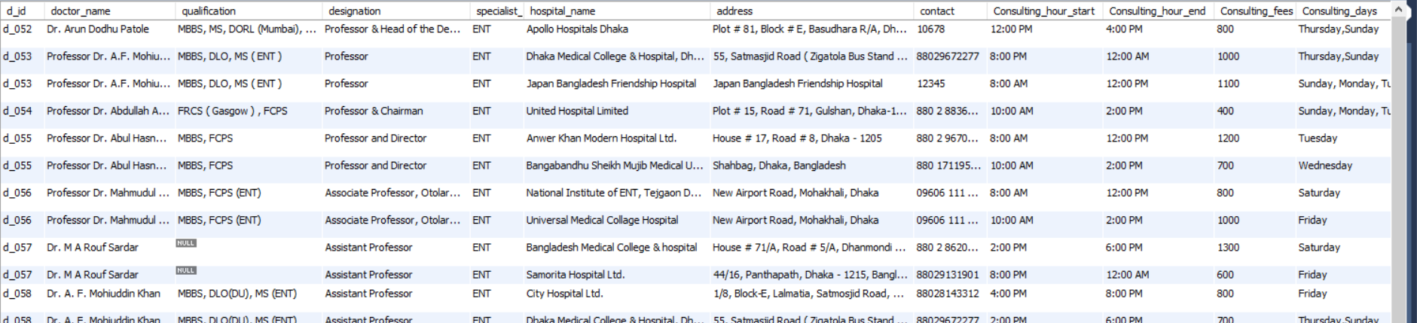

**3. Find doctor by hospital name.**

**EX: Hospital name = LabAid Ltd**

**SELECT**

**\***

**FROM**

**doctors**

**WHERE**

**d_id IN (SELECT**

**d_id**

**FROM**

**works**

**WHERE**

**h_id IN (SELECT**

**h_id**

**FROM**

**hospitals**

**WHERE**

**hospital_name REGEXP 'LabAid'));**

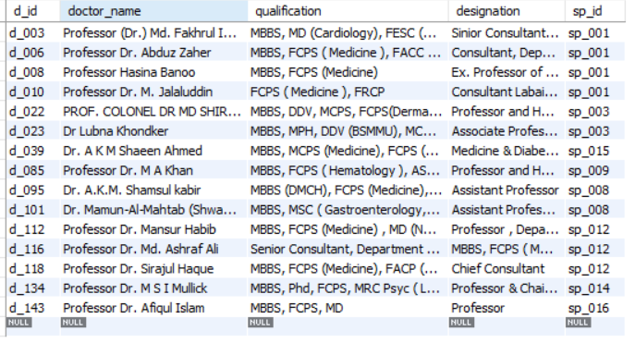

**4. Find doctor using location and specific specialist name:**

**EX: Dhanmondi and Dermatology, Dhanmondi and Medicine, Gulshan and Neuromedicine**

SELECT

doctor_name,

qualification,

specialist_name,

hospital_name,

address,

contact,

Consulting_hour_start,

Consulting_hour_end,

Consulting_fees,

Consulting_days

FROM

doctors_full_information

WHERE

specialist_name REGEXP '^Dermatology'

AND d_id IN (SELECT

d_id

FROM

doctors

JOIN

works USING (d_id)

JOIN

hospitals USING (h_id)

WHERE

h_id IN (SELECT

h_id

FROM

hospitals

WHERE

hospital_name REGEXP 'Dhanmondi'));



**5. Search doctor by hospital and Specialist. Like Cardiology (Heart) specialist from popular hospital**.

SELECT

d.doctor_name,

d.qualification,

d.designation,

w.Consulting_hour_start,

w.Consulting_hour_end,

w.Consulting_fees,

w.Consulting_days

FROM

doctors d

JOIN

works w USING (d_id)

WHERE

sp_id = (SELECT

sp_id

FROM

specialists s

WHERE

specialist_name REGEXP '^Cardiology')

AND h_id IN (SELECT

h_id

FROM

hospitals h

WHERE

hospital_name REGEXP 'popular');



**6. Find symptoms of specific specialist sector. Like cardiologist, ENT**

SELECT

symptom

FROM

symptoms

WHERE

sp_id IN (SELECT

sp_id

FROM

specialists

WHERE

specialist_name REGEXP '^Cardiology');

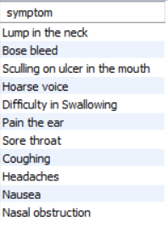

**7. Search doctors by name and specialist. Ex. Details of “Dr. A.K.M. Nazmus Saquib” and specialist “Eye”**

SELECT

*

FROM

doctors_full_information

WHERE

d_id IN (SELECT

d_id

FROM

doctors

WHERE

doctor_name REGEXP 'Dr. A.K.M. Nazmus Saquib'

AND sp_id = (SELECT

sp_id

FROM

specialists

WHERE

specialist_name REGEXP '^Eye'));



**8. Is a doctor available or not available on the specific days in hospital search by doctor name and hospital name.**

**Ex: “Professor Dr. M. Nazrul Islam” in “Popular Diagnostic Centre” Hospital is available today.**

SELECT

IF((SELECT

d_id

FROM

doctors_full_information

WHERE

doctor_name REGEXP 'Professor Dr. M. Nazrul Islam'

AND hospital_name REGEXP 'Popular Diagnostic Centre'

AND Consulting_days REGEXP (SELECT DAYNAME(CURDATE()))) IS NULL,

'Not Available today',

'Available today') AS Status;



**9. Get doctors information on specific specialist and consulting fees low to high.**

**Ex: Specialist “Medicine”**

SELECT

*

FROM

doctors_full_information

WHERE

d_id IN (SELECT

d_id

FROM

doctors

WHERE

sp_id = (SELECT

sp_id

FROM

specialists

WHERE

specialist_name REGEXP '^Medicine'))

ORDER BY Consulting_fees;

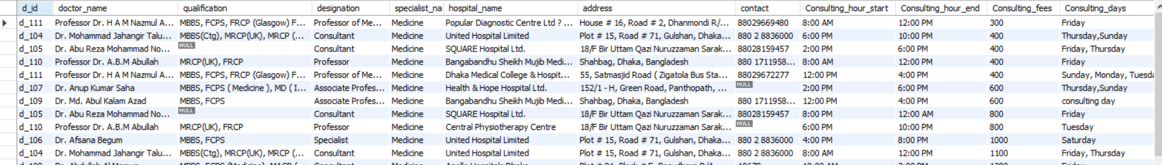

**10. Search Which doctors don't work in any hospital.**

**Subquery:**

select *

from doctors

where d_id not in(select d_id from works);

**Join:**

select *

from doctors

right join works using(d_id)

where h_id is null;

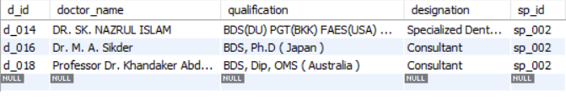

**11. Number of doctor’s work in each hospital.**

SELECT

h.hospital_name, COUNT(w.d_id) AS 'Number Of Doctors'

FROM

hospitals h

JOIN

works w USING (h_id)

GROUP BY h_id;

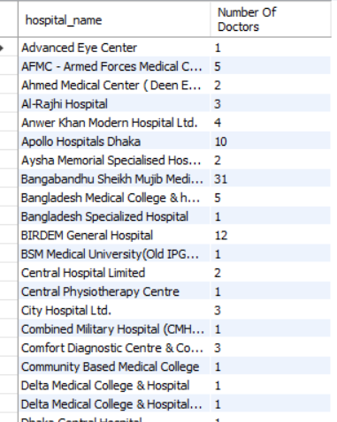

**12. Find doctors information using “specialist name”, “week days name” and “location”.**

**EX: specialist name = Cardiology**

**Location = Dhanmondi**

**Day = Friday**

SELECT

*

FROM

doctors

WHERE

sp_id = (SELECT

sp_id

FROM

specialists

WHERE

specialist_name REGEXP '^Cardiology')

AND d_id IN (SELECT

d_id

FROM

hospitals

JOIN

works USING (h_id)

WHERE

address REGEXP 'Dhanmondi'

AND Consulting_days REGEXP 'Sunday');

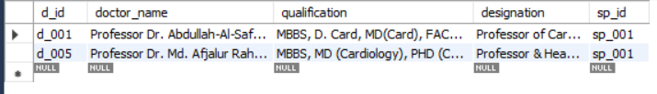

**13. Find doctors whose consulting fees low in a specific specialist.**

**EX: specialist name = Cardiology**

SELECT

*

FROM

doctors_full_information

WHERE

specialist_name REGEXP '^Cardiology'

AND Consulting_fees = (SELECT

MIN(consulting_fees)

FROM

doctors_full_information

WHERE

specialist_name REGEXP '^Cardiology');



**14. Find top 5 hospital where maximum number of doctor’s work in hospital. Show row number.**

SELECT

row_number() over(ORDER BY t.Number_of_Doctors DESC) as 'Row Number',

t.hospital_name,

t.Number_of_Doctors

from (

SELECT

hospital_name, COUNT(d_id) AS Number_of_Doctors

FROM

hospitals h

JOIN

works w USING (h_id)

GROUP BY h_id

ORDER BY Number_of_Doctors DESC

LIMIT 5) as t;

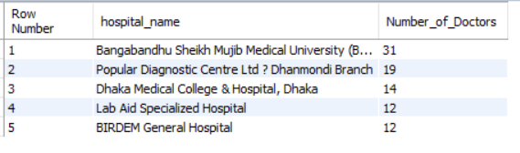

**\*\*15. Find doctors on basis of given symptoms. If symptoms are not match with any specialist name then show medicine specialist doctors**.

**EX: symptoms: Bose bleed**

**Sculling on ulcer in the mouth**

**Coughing**

**Headaches**

**Irregular periods**

**A fast heart beat**

SELECT

*

FROM

doctors

WHERE

sp_id = (SELECT

IFNULL((SELECT

x.sp_id

FROM

(SELECT

sp_id, COUNT(sp_id) AS c

FROM

symptoms

WHERE

symptom REGEXP 'Bose bleed|Sculling on ulcer in the mouth|Coughing|Headaches|Irregular periods|A fast heart beat'

GROUP BY sp_id

ORDER BY c DESC

LIMIT 1) AS x),

'sp_010')

);

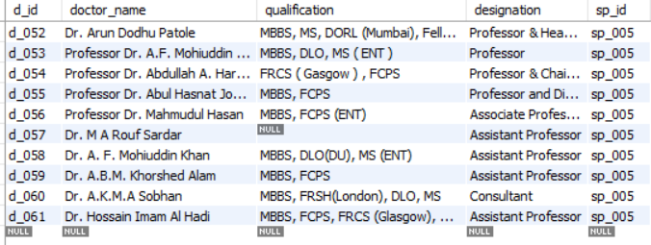

**Conclusion**

This is a project on the health sector. We are trying to get all the information that need to show or represent doctor information. And we are also trying to make relation between symptoms and doctor. If someone give symptoms, we are suggesting the right doctors on the specific sector on the basis of symptoms in the query (15). In future, we will apply “Machine Learning” on this project.